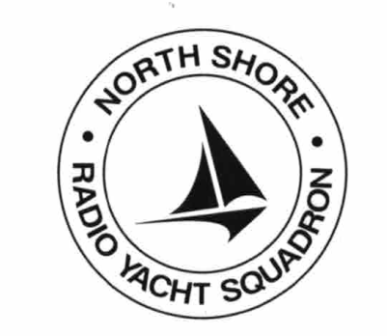
NOTICE OF RACE

North Shore Radio Yacht Squadron

2022 GEOFF SMALE IOM MEMORIAL REGATTA

North Shore Radio Yacht Squadron invites you to participate in the delayed 2022 IOM Geoff Smale Memorial regatta

DATE: Wednesday 25th January 2023 (one day regatta)

ORGANISING AUTHORITY: North Shore Radio Yacht Squadron

VENUE: Quarry Lake, Northcote Road, Takapuna, Northshore

ELEGIBILITY: This regatta is open to all NZRYA affiliated members in good standing with the NZRYA, or the Delegated National Member (DNM)of their country of residence. All boats must have a current registration certificate.
RULES: The racing will be governed by the Rules of Sailing 2021 -2024. respect for your fellow sailors and having a good time, as Geoff would expect.
RACE FORMAT: HMS

RACING: Wednesday 25th January 2023
Registration 09:30 am
Briefing 09:45 am
First Race 10:00 am
Last Race 3:00 pm – or at Race Officers discretion.
Lunch No lunches provided
Prize Giving ASAP following completion of final race.
Complimentary BBQ & drinks Included in entry fee - follows immediately after prize-giving.

ENTRIES and FEE: Entries on the day up to 9.30 am. The fee is $15.00 (correct amount please) payable to the Treasurer (John Dalton).
All proceeds to be retained to assist NSRYS member(s) entering the IOM Worlds.

SAILING INSTRUCTIONS Shall be given verbally at the briefing

ENQUIRIES TO: Commodore - Graham Cross
Mob: 020 4129 7350

